AP CS A Celebrity Lab Checklist

1. Work through Lab exercises on paper for parts 1-3
2. Write Celebrity.java (2)
3. Write the PSVM in CelebrityRunner
   1. Create a CelebrityGame instance
4. Finish CelebrityGame.java (3)
   1. Data members
      1. Celebrity instance gameCelebrity
      2. ArrayList<Celebrity> instance celebGameList
      3. CelebrityFrame instance gameWindow
   2. Constructor
      1. Initialize data members
      2. Call prepareGame helper
   3. Methods
      1. Complete prepareGame
      2. Complete game size method
      3. Complete Celebrity related methods
         1. sendClue
         2. sendAnswer
      4. Complete validation methods
         1. validateCelebrity
         2. validateClue
      5. Complete addCelebrity
      6. Complete play
         1. Check the size of the ArrayList<Celebrity>
         2. Set the current celebrity
         3. Call the replaceScreen method properly
      7. Complete processGuess
         1. Use the String methods equalsIgnoreCase(text) and trim() on the parameter
      8. Complete sendClue()
5. Complete the CelebrityFrame class (GUI Appendix)
   1. Constructor  
        
      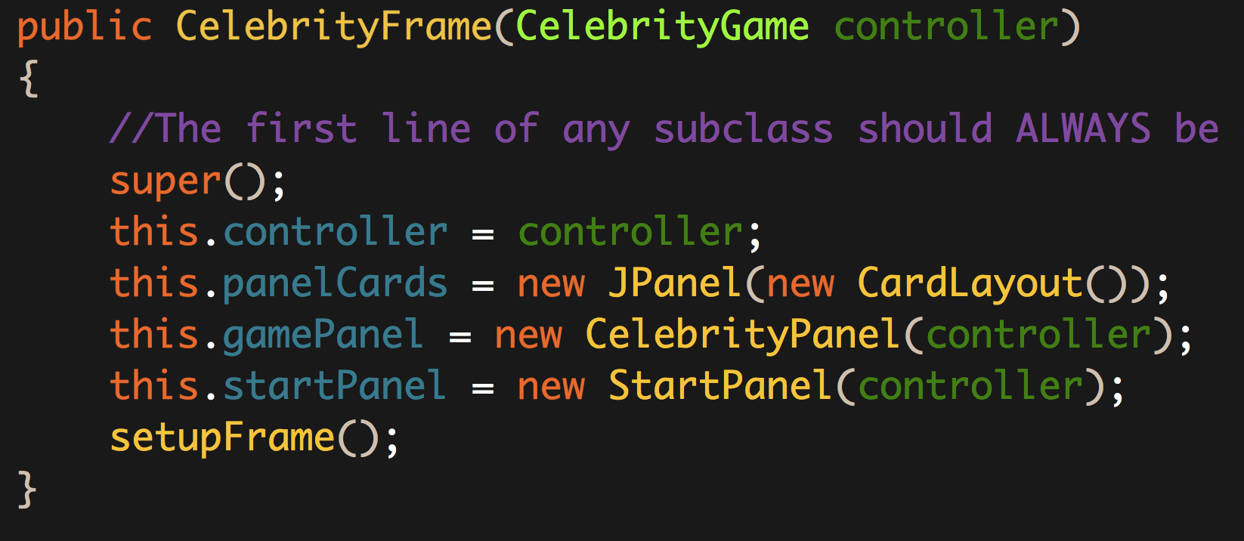
      1. Leave the super() call where it is
      2. Initialize the controller data member from the parameter
      3. Initialize the three panels
         1. panelCards with a parameter of a new CardLayout()
         2. gamePanel with a reference to the controller as a parameter
         3. startPanel with a reference to the controller as a parameter
         4. Call the setupFrame helper
   2. setupFrame helper method  
        
      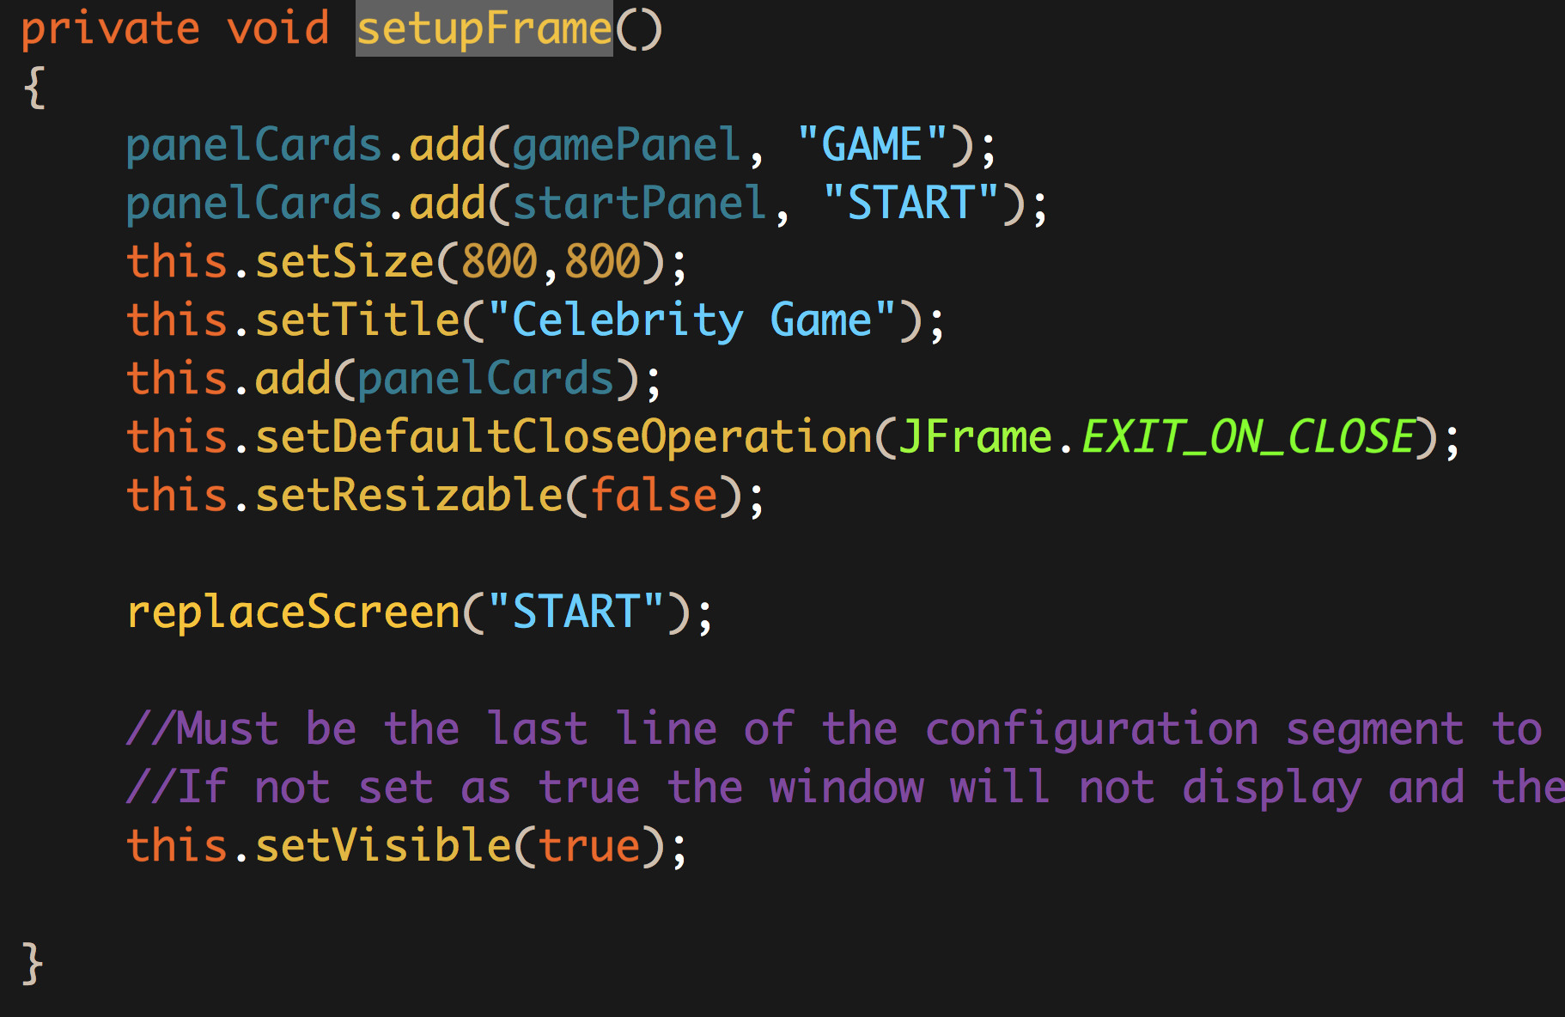
      1. Add the gamePanel and startPanel to the panelCards member with the Strings GAME and START respectively
      2. Set the size of the frame to 800 by 800
      3. Set the title to be Celebrity Game
      4. Add the panel cards to the frame
      5. Set the default close operation
      6. Set the window to NOT be resizable
      7. Call replaceScreen with a parameter of START
      8. Set the window to be visible!!
   3. replaceScreen method  
        
      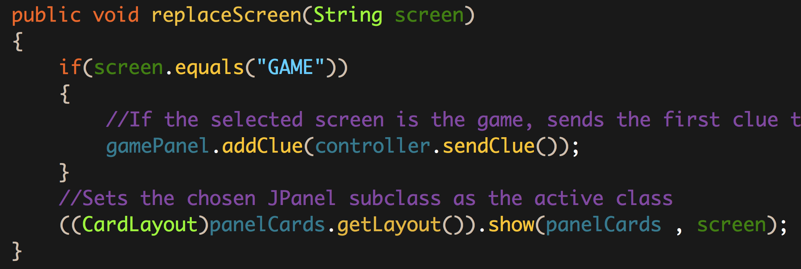
      1. Check the if the parameter equals GAME
         1. If it does, call gamePanel.addClue with a parameter of controller.sendClue()
      2. Tell the panelCards layout manager to show the correct screen
6. Complete the StartPanel class
   1. The setupPanel helper method  
        
      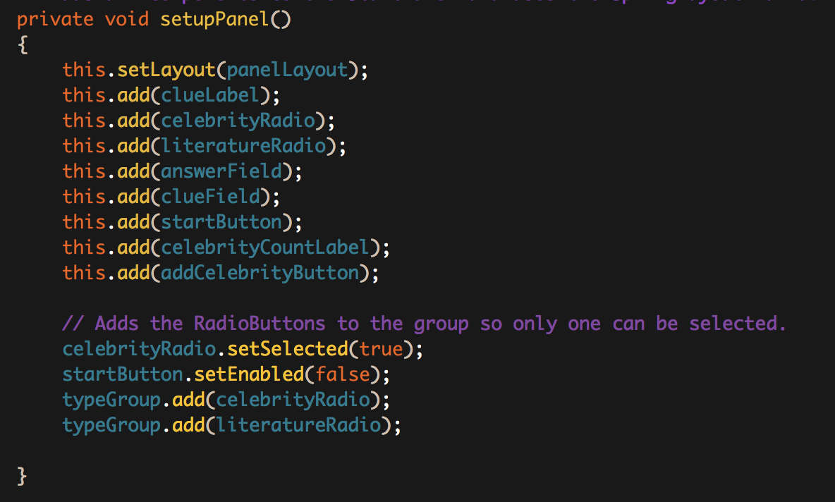
      1. Set the layout manager
      2. Add all the GUI components
         1. clueLabel
         2. celebrityRadio
         3. literatureRadio
         4. answerField
         5. startButton
         6. celebrityCountLabel
         7. addCelebrityButton
      3. Set the default type of Celebrity
      4. Enable the startButton
      5. Add both RadioButtons to the typeGroup